JOSEPH TABUA 10164945
Reflection on Practice Essay
Title: Empirical and Heuristic: A Collaborative Methodology Research Inside Fine Music Radio 102.5 FM
Project Rationale: Observational Research and Interactive Processes
My intention was to explore the radio broadcast institution Fine Music 102.5 FM, in collaboration with David Nolan whose focused area of research towards the technical practicalities. The organization’s music engages to a large extent in the Classical and Opera genre. (Fine Music 102.5, 2014) states: While Fine Music 102.5 is predominantly a classical music station it also has programs featuring jazz, world, folk and contemporary music. I employed a qualitative analysis strategy to explicate the research, as cited in (Punch, 1998, p. 119) Miles & Huberman states, the researchers role is to gain a holistic overview of the context under study: its logic, its arrangements, its explicit and implicit rules. Coming to understand the interconnections among visual forms, patterns of inquiry and different perspectives offers the possibility of making intuitive and intellectual leaps towards the creation of knowledge. With these succinct ideologies underpinning the evolution of my research, this permitted a diligent study to emerge and set in motion the lucidity of the collaborative practice led-research. (Loftland 1971) asserts: It is the observer’s task to find out what is fundamental or central to the people or world’s under observation. Loftland’s opinion compelled Nolan and I to maintain this theory, for the reason it was consistent, and it placed the tools of observation and reflection directly in our hands. It was particularly beneficial owing to the fact of the limited time frame we had to conduct the research. While in the field I observed relationships and the inner sanctum of some of the presenters. Most presenters were friendly and some not so genial, however, by developing the right questions, I was able to identify both positive and negative issues. Fine music operates through the idea of the professional/amateur application, in which the main focus for operations is the broader community. The professionals that inhibit Fine music come from various backgrounds and it is this viewpoint that contributions come in many shapes and forms, by way of donations from listener-ship, arts partner-ship, on air sponsors, Sydney Symphony Orchestra, Sydney Chamber Orchestra, Huntington Estate and the Willoughby City Council. Working at Fine Music in an internship capacity helped me to build a rapport with the staff and volunteers; which made the acquired research materials affluent. The interactions through social and professional work routines generated a significant amount of data, not in the conventional sense of numeric information in which this would be viewed as a quantitative study, however, a narrative account of events that exhibit characteristics of a qualitative research practice. The majority of reflection and processing was mobilised through my personal Word Press website, where at the end of each working day I would enter data such as photos, notes from the subscription magazine and transcripts of interviews that I had conducted.
Figure 1. Joseph Tabua Word Press Website. http://josephtabua.wordpress.com/
Proving beneficial to the research also was my cellular phone, with its convenient recording capabilities, enabling a logical interpretation to be documented and most importantly the ability to delineate all new research results acquired. Through collaboration with David Nolan I adapted this recording technique, Nolan is an advocate for new technology, as I am not quite technologically progressive. The collaborative experience was an interesting, yet insightful process, presenting very few difficulties and the practice of collaboration enriched the quality of the research. Managing issues was made easier by reason of the ability to communicate verbally as opposed to the personal day-to-day internal monologue that transpires in self-reflection (self doubt), can often impede the research. My individual research approach involved interviews, observations inside the station, on-line presence, and diary entries. The later was most useful on account of our limited time frame and the availability of participants (presenters) each time I was on-site. As the project progressed most noticeable was the impact and significance of researching research itself. (Schön, 1987, p. 161) speaks about this materialization that occurs inside individual research when he asserts: A designer’s reflective conversation with the materials of a situation can yield new discoveries, meanings, and inventions.
All correspondence was carried out via e-mail with the program director Steve-Marc Mculloch, whose expertise and advice was invaluable. Most interviews and concert recordings on-site were coordinated by Mculloch, with the exception of General Manager Liz Terracini, whom in the beginning, together with our supervisor Diana Blom initiated the music project. One of the ways in my research asked the following questions to twenty presenters over the course of three months.
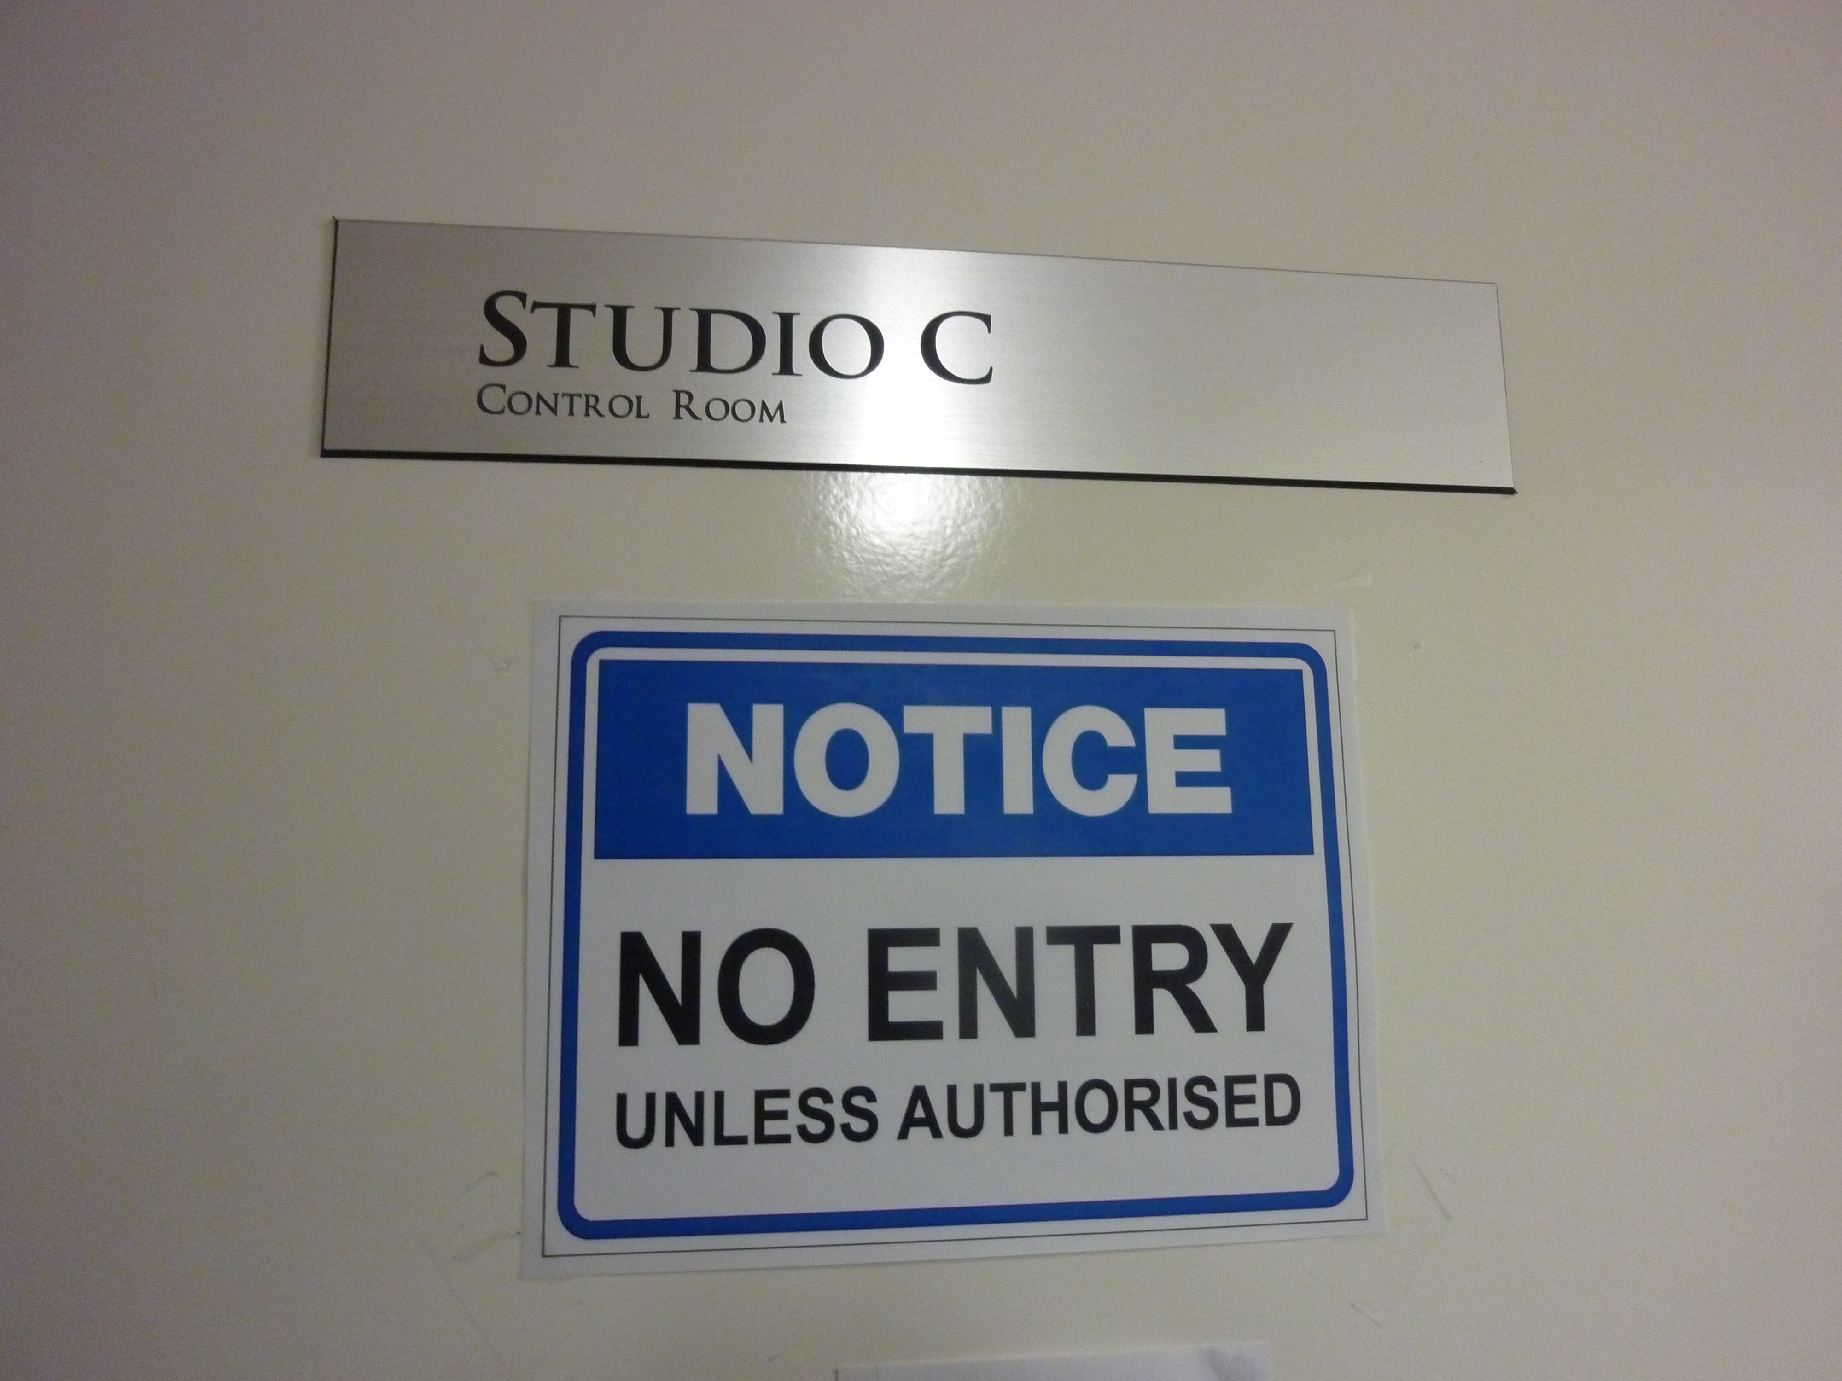
Live to air- Studio C
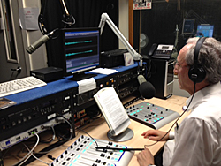
Presenter Michael Field- Studio B

Presenter David Brett- Studio A
This was called the five-minute interview. (Tabua, 2014)
1. What is the name of your program and what genre of music do you specialise in?
2.How long does the program run and what time is it on?
3.How long does it take to assemble your program?
4.What relationship do you have with listeners? (Philosophical/reflective)
5.Have you had any formal training?
6.How did you become involved with Fine Music?
The answers to the six questions put forward in each interview at times took longer than 5 minutes. This advantageous formula was now producing factual data and illustrating significant historical and present-day moments in the assembly of the Fine Music organization. In addition, individual accounts and personal feelings yielded a plethora of information, which was then documented ethically, keeping in mind that the public portal was accessible to not only my academic peers but also the Fine Music organization.

Presenter Sally Cameron
Here is an excerpt from an interview I conducted with presenter, Sally Cameron, who studied at The Elder Conservatorium of Music in Adelaide.
JT: What is the name of your program and what genre of music do you specialise in?

SC: It’s called Friday night Jazz session, so it’s exactly what it sounds like, it’s the 7pm session on Fridays, one hour of Jazz and I’m a professional Jazz musician. I play say fifty-fifty per cent Australian contemporary Jazz and then old school as well.
JT: How long does it take to assemble your program?
SC: It's different week to week but I’m often, umm sometimes I want to promote certain things that are coming up like for e.g. I’ve just done a pre-recorded for the next show, which I want to promote a show that is happening on the Saturday night, so I’m playing Mark Isaacs and bits and I’m playing his tunes.
JT: Have you had any formal training?
SC: No, just training here at Fine Music
JT: Onsite? That’s great!
JT: This is the last one, how did you become involved with Fine Music radio?
SC: I was interested in becoming a jazz presenter about four years ago. I spoke to my friend Emma Paske about it and we both thought, why don’t we just ring up and see how we go, this was at another station actually and they let us both start on the midnight show, (LAUGHS) and sort of cut our teeth on that, so I spent a couple of years there and then I was asked to come and join here at Fine music.
JT: Sally, thank you so much for answering those questions
SC: You’re welcome
Remarkably, this interview conveyed awareness that presenters enter the organization from many diverse backgrounds, as novices and also from the academic milieu. Regardless of skill or experience this organization reaches out to the broader community significantly by providing opportunities for both fans and the music aficionado.

Contextual Relationship: Phenomenology
The interior of Fine Music is a privileged dwelling, with many elite composers and performers walking through its narrow hall ways, frequently visiting for the reason of media commitments and the occasional live to air performances. To be consistent as a researcher I found practical guidance through sociologist literature and adopted the following elements into my own observations as cited in (Patton, 1980, pg. 36)
Lofland 1971 states:
1. The qualitative methodologist must get close enough to the people and situation being studied to be able to understand the depth and details of what goes on.
2. He must aim at capturing what actually takes place and what people actually say: the perceived facts.
3. Qualitative data consist of a great deal of pure description of people, activities, and interactions.
4. Qualitative data consist of direct quotations from people, both what they speak and what they write down.
To illustrate pertinent data, here is a brief video of a volunteer Helen Milthrorpe explaining but one of her roles at the organization.
Adding to the video is a diary entry excerpt from the 20th August, which can be viewed in its entirety on the Word Press portal.
What are people’s perceptions? Milthorpe explains:
The librarian’s duty is to collect what the presenter has written down on a word document and the librarian is there to see if any errors arise. For E.G song duration
• observing the librarians role inside the 102.5 FM this morning has been a very insightful and prescient undertaking that must take place for a program to materialize.
•All cover sheet playlists are kept because once every month the playlist cover sheets are viewed by APRA/AMCOS in order for royalties to be allocated to composers and or performers.
•Helen’s work is of acute awareness concerning programming and perceptions that help FINE music remain in the community’s consciousness. Helen’s work at Fine Music FM is of a volunteer capacity.
Another highlight to the morning was to see the radio stations commitment to assisting persons with disabilities in the community. I was introduced to a young adult Alex who was assisting in the library department; he was resetting CD’s in the archive.
The heuristic (interactive) approach to learning about something hands on can be viewed with much encouragement and has contributed to this specific research. The notion held by Bolt regarding material practice and the emergence of new information through handling has generated a framework that creative arts researchers can put into practice.
Culmination and Negotiation
Fine Music at present has 290 volunteers, 32 presenters, 10 paid staff, and 8 directors. Over the course of 3 months I interviewed 15 presenters, 8 volunteers, 3 librarians and the study revealed the significance of the broader community. The impact of community has generated a successful and functional radio environment. My greatest concern is the manner in which these experts (presenters) conduct themselves in social settings, at times there appeared to be an elitist feeling and resentment from co-workers. Issues in the work place are often unspoken and indignation may surface, however, in this organisation there appeared to be no prejudicial circumstances. To comprehend a great deal more from this organization, it would have been most useful to conduct this research over a longer period of time, perhaps 6-12 months, to gain a richer understanding of the Fine Music institution. Over recent years their financial supporters have declined markedly in number, yet they face rising operational costs, and the need to finance the world-class recording and broadcasting facilities they now possess and the capability to support emerging musicians. Along with similar organizations, they we’re finding that traditional means of attracting support for their activities are failing. Competing requests for the “charity dollar” and the rise of alternative media mean that the old methods are ineffective. The findings from the research revealed that being immersed in the Fine music environment proved to be both a valuable and challenging experience. Research expectations and ethical considerations made some participants quite reticent, however, there were many other enthusiastic candidates willing to participate in the research. I also recognised it is largely an investigative process where the researcher gradually makes sense of a social phenomenon by contrasting, comparing, replicating, cataloguing the object of study.

References
Bolt, B. (2006). A Non Standard Deviation: Handlability, Praxical Knowledge and Practice Led Research.
Fine Music 102.5. (2014). >> Our Presenters - Fine Music 102.5.
Retrieved from http://www.finemusicfm.com/our-presenters.html
Lofland, J. (1971). Analyzing social settings: A guide to qualitative observation and analysis. Belmont, CA: Wadsworth Pub. Co.
Patton, M. (1980). Qualitative evaluation methods. Beverly Hills: Sage Publications.
Punch, K. (1998). qualitative research design. In Introduction to social research: Quantitative and qualitative approaches (p. 119). London: SAGE Publications.

Schön, D. A. (1987). Educating the reflective practitioner: Toward a new design for teaching and learning in the professions. San Francisco: Jossey-Bass.

Smith, H., & Dean, R. T. (2009). Practice-led research, research-led practice in the creative arts. Edinburgh: Edinburgh University Press.

Tabua, J. (2014). Joseph Tabua | music researcher, composer. Retrieved from http://josephtabua.wordpress.com/

Fine Music 102.5. (2014). >> Our Presenters - Fine Music 102.5. Retrieved from http://www.finemusicfm.com/our-presenters.html
Punch, K. (1998). qualitative research design. In Introduction to social research: Quantitative and qualitative approaches (p. 119). London: SAGE Publications.
Smith, H., & Dean, R. T. (2009). Practice-led research, research-led practice in the creative arts. Edinburgh: Edinburgh University Press.
Lofland, J. (1971). Analyzing social settings: A guide to qualitative observation and analysis. Belmont, CA: Wadsworth Pub. Co.
Schön, D. A. (1987). Educating the reflective practitioner: Toward a new design for teaching and learning in the professions. San Francisco: Jossey-Bass.
Tabua, J. (2014). Joseph Tabua | music researcher, composer. Retrieved from http://josephtabua.wordpress.com/
Patton, M. (1980). Qualitative evaluation methods. Beverly Hills: Sage Publications.
Tabua, J. (2014). Joseph Tabua | music researcher, composer. Retrieved from http://josephtabua.wordpress.com/
Bolt, B. (2006). A Non Standard Deviation: Handlability, Praxical Knowledge and Practice Led Research.

